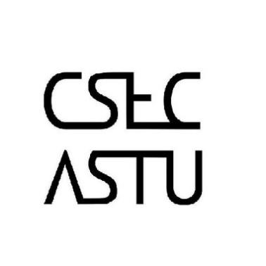

**Call for all Students who registered for CSEC-Dev’t**

**There will be an orientation by the CSEC-Dev’t division head regarding the activities and procedures of the division.**

**Venue** – B-508 R-9

**Time**  – Wednesday , November 14, 2018

Attendance is Mandatory!!!

**Follow US on social Media for more updates…**

